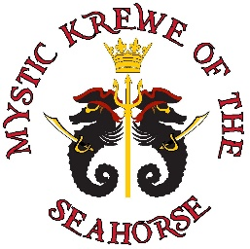
SPONSORSHIP CONTRACT
Sponsor Level | Check One
Captain - $5,000

Quartermaster - $2,500

First Mate - $1,000

Boatswain - $500

Pirate - $250

- Deadline for Logo and Financial Pledge is December 15, 2023
  - Forms submitted to Trudy Ehrich trudyinnola@yahoo.com
  - Logos submitted to Robin Copeland robincopeland64@gmail.com

- Deadline for Payment is January 26, 2024
  - Payment Options
    - Make check payable to MKOTSH (Contact Trudy Ehrich for pick up)
    - Alternatively, mail you check to:
MKOTSH
998A Hwy 90
Bay St. Louis, MS 39520
Attn: Dina Rosetti
- Pay Online
- Portal Link: mkotsh.com/sponsor

Please complete the following information and return this form with your check.
Business Name _________________________________________________________
Contact Person _________________________________ Phone Number ___________
Address _______________________________________________________________
City ______________________________ State ______ Zip ______________________
Email _________________________________________________________________
Any questions please contact Trudy Ehrich at (504) 915-7881 or trudyinnola@yahoo.com

